CONGRATULATIONS TO
OUR FIRST EVER PIAA
STATE WRESTLING CHAMPION!

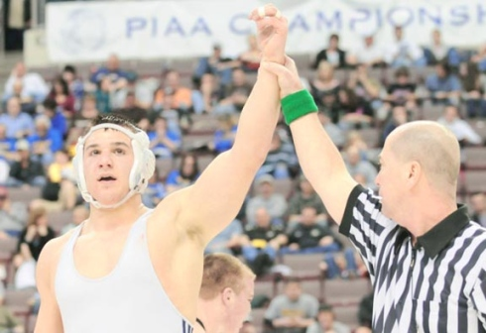

GARTH LAKITSKY

