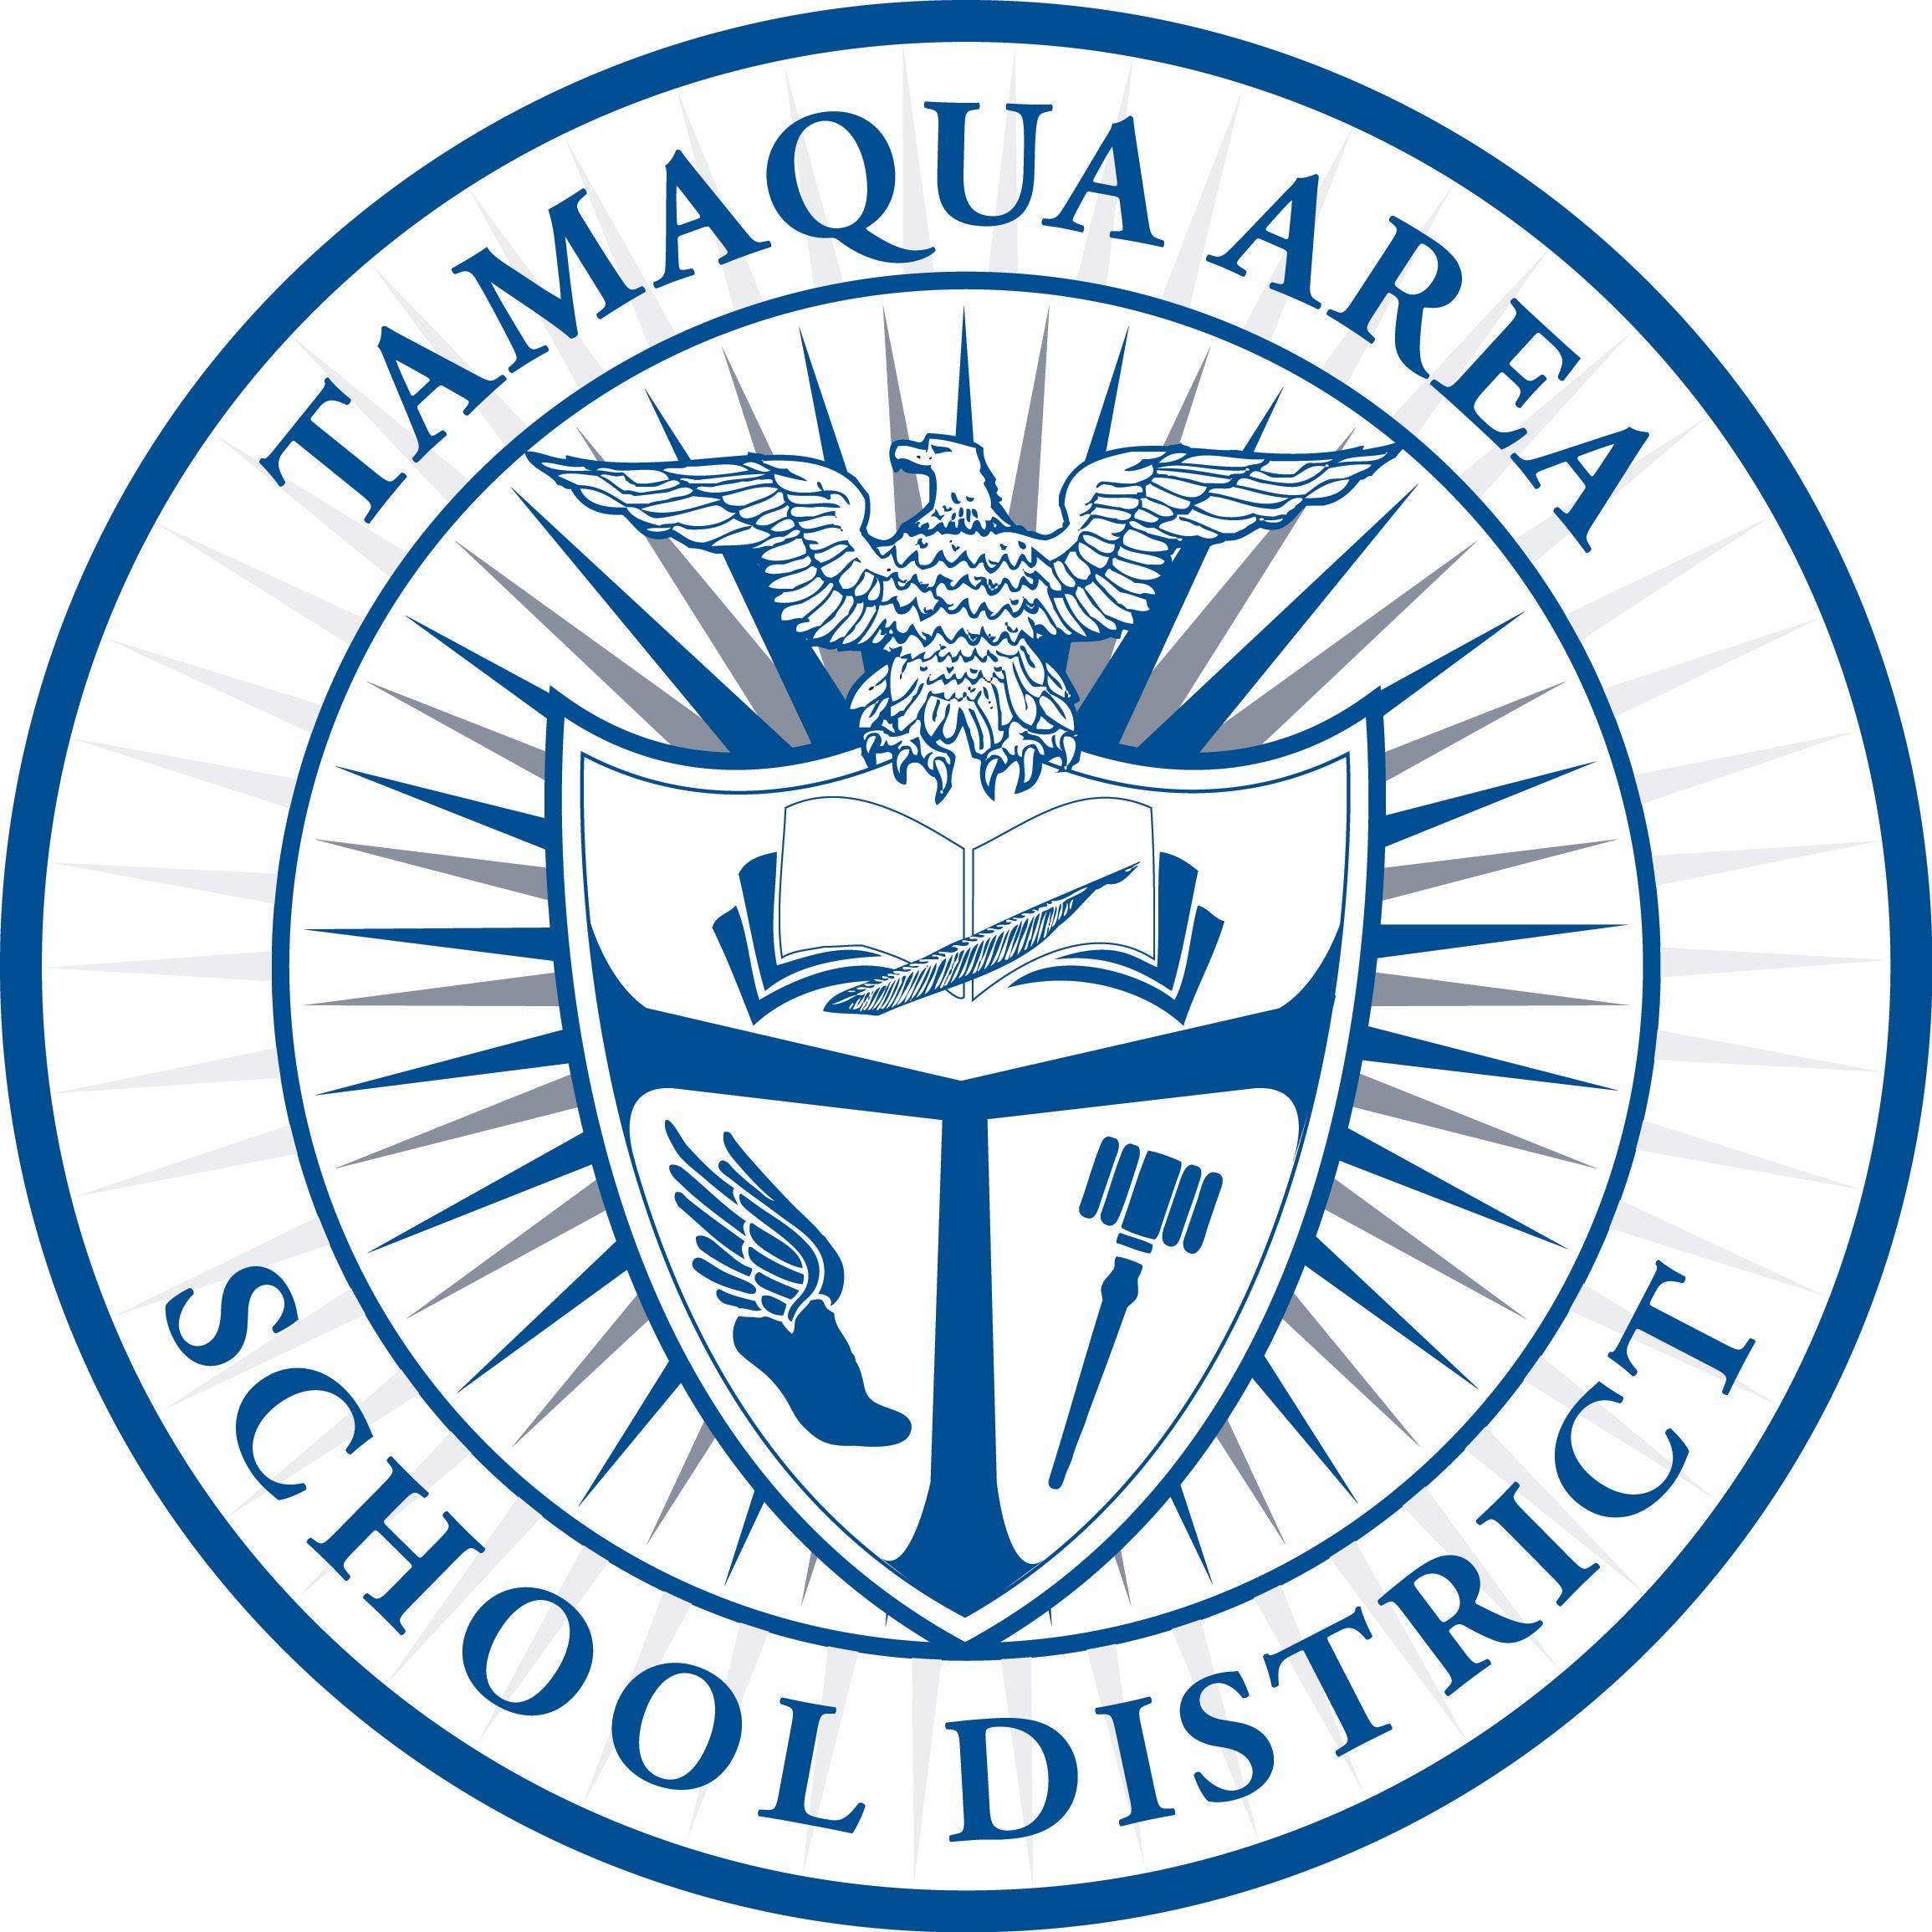
JOB DESCRIPTION: Head Coach 2023

Qualifications:
*Acceptable criteria screened by Athletic director and Principal.
*Approved by both Superintendent and Board of Education.

Reports To:
*Athletic Director and Building Principal.

Supervises:
*All paid and volunteer coaches of the program.
*All athletes involved with the entire program (directly/indirectly).

Job Goal:
*To be a teacher of the fundamentals and the fine points of the sport assigned.
*To develop the individual and collective skills.
*To provide supervision and guidance.
*To reflect the philosophy of the school and of the athletic program.

Performance Responsibilities:
*Become familiar with and implement the rules of the Pennsylvania Interscholastic Athletic Association (P.I.A.A.) at all times.
*Attend a P.I.A.A. rules interpretation meeting.
*In addition to utilizing the Tamaqua Area School District’s Code of Conduct for Student-Athletes, the head coach must develop and distribute team rules, regulations, and standards in accordance with school policies. These discipline codes should be handed out to the athletes at the beginning of the season, signed by the student and parent or guardian, and returned to the head coach. This policy must be presented to the Athletic Director before each season for approval.
*Make sure that each athlete has received a physical examination prior to the beginning of the season with the P.I.A.A. paperwork properly signed and filled out prior to any type of participation, including practice. No Student may practice or participate without a signed physical.
*Supervise participants at all times. A member of the coaching staff is always the last one to leave a practice or a game.
*Treat all participants equally.

*Check academic eligibility each Monday and follow school district rules as to participation regarding eligibility.
*Consider the well-being of all participants over and above all else.

*Notify the Athletic Director of any major problems occurring at practice or games.

*Know and use the proper techniques for training and warming up of players.

-More-
*Ensure that equipment is in proper condition for use.

*Be responsible for the conduct of all of the players at all practices and contests.

*Supervise all activities during practice.

*Leave the playing fields/courts, practice areas, locker rooms, opponents facilities in as tidy and neat condition as they were found. Lights and showers off, toilets flushed, trash and tape thrown in the proper receptacles.

*Secure all buildings and practice areas when necessary.

*Be responsible for the distribution and collection of all equipment, uniforms, and supplies issued to the sport. Failure to collect equipment at the end of a season may result in the holding of your payment.

*Ensure that all scores and information from games are reported to the newspapers in a prompt and accurate manner.

*Set up a method of communication for contacting team members in the event of cancellations or any changes.

*Prepare REQUISITIONS for the next year in a timely manner.

*Keep an accurate INVENTORY list of all equipment and uniforms and prepare an inventory summary sheet which is to be submitted to the Athletic Director on a yearly basis.

Terms of Employment:
*A yearly contract must be signed after being approved by the Board of Education.

Evaluation:
*Performance of this position will be evaluated annually by the athletic director and/or principal.

