Tamaqua – 36
Tri_Valley – 29

119 C. Kievman TV t-fall 5:28 21-4 Tom Robin
125 Phil Christman T wbd 5-0 Brandon Bordner
130 Kolby Mashack T wbf 1:51 Alex Snyder
135 Sam Scheib TV wbmd 12-3 Seth Mellor
140 Jon Glosek TV wbmd 15-4 Matt Edmonds
145 Dan Koppenhaver TV wbmd 19-6 Anthony Houser
152 Justin Miller T wbd 1st o.t 8-6 Bryn Bowman
160 Ryan Oldt T wbf 1:59 Brock Klinger
171 Cody Troutman TV wbf 5:48 Jarred Folweiler
189 Garth Lakitsky T wbf 5:58 Jasen Krammer
215 Dustin Wentz T wbf 4:21 Travis Newton
185 Brandon Danko T wbf 2:26 Chad Weikle
103 Josh Wolfgang TV wbff
112 double ff

Match Date: 1/31/2009
Match Results for School: Tamaqua Area HS
Opponent School: PINE GROVE AREA HS
Tamaqua Area HS: 37
PINE GROVE AREA HS: 27
112: LEHMAN, TY (PINE GROVE AREA HS) For (Tamaqua Area HS) -
119: RITTENBAUGH, KODY (PINE GROVE AREA HS) FALL ROBIN, TOM(Tamaqua Area HS) 3:14
125: FEGLEY, JUSTIN (PINE GROVE AREA HS) DEC CHRISTMAN, PHILIP(Tamaqua Area HS) 4-2
130: MASHACK, KOLBY (Tamaqua Area HS) TF WOLFF, ALLEN(PINE GROVE AREA HS) 3:44
135: DIETRICH, MATT (PINE GROVE AREA HS) DEC MELLOR, SETH(Tamaqua Area HS) 6-4
140: DONOFRIO, TRENT (PINE GROVE AREA HS) DEC EDMONDS, MATT(Tamaqua Area HS) 6-5
145: Houser, Anthony (Tamaqua Area HS) DEC DAUBERT, ALLEN(PINE GROVE AREA HS) 12-9
152: Miller, Justin (Tamaqua Area HS) FALL ZIMMERMAN, TOBIE(PINE GROVE AREA HS) 2:55
160: Oldt, Ryan (Tamaqua Area HS) TF Elvin, Justin(PINE GROVE AREA HS) 5:07
171: LENGLE, CHIP (PINE GROVE AREA HS) FALL FOLWEILER, JARRED(Tamaqua Area HS) 3:13
189: LAKITSKY, GARTH (Tamaqua Area HS) For (PINE GROVE AREA HS) -
215: WENTZ, DUSTIN (Tamaqua Area HS) FALL BETZ, MICHAEL(PINE GROVE AREA HS) 5:12
285: DANKO, BRANDON (Tamaqua Area HS) FALL SANTOS, JEFF(PINE GROVE AREA HS) 5:44

Match Date: 1/21/2009
Match Results for School: Tamaqua Area HS
Opponent School: POTTSVILLE AREA HS
Tamaqua Area HS: 54
POTTSVILLE AREA HS: 21
103: Mills, Brandon (POTTSVILLE AREA HS) For (Tamaqua Area HS) -
112: Harris, James (POTTSVILLE AREA HS) For (Tamaqua Area HS) -
119: ROBIN, TOM (Tamaqua Area HS) DEC Bickelman, Joseph(POTTSVILLE AREA HS) 8-6
125: Goodman, Adam (POTTSVILLE AREA HS) DEC CHRISTMAN, PHILIP(Tamaqua Area HS) 4-2
130: MASHACK, KOLBY (Tamaqua Area HS) TF Schwalm, Justin(POTTSVILLE AREA HS) 15-0
135: MELLOR, SETH (Tamaqua Area HS) FALL Petchulis, Brad(POTTSVILLE AREA HS) 1:32
140: EDMONDS, MATT (Tamaqua Area HS) TF Guyer, Kurtis(POTTSVILLE AREA HS) 18-3
145: Houser, Anthony (Tamaqua Area HS) FALL Specht, Zack(POTTSVILLE AREA HS) :57
152: Miller, Justin (Tamaqua Area HS) FALL Laubach, Teagan(POTTSVILLE AREA HS) 1:00
160: Oldt, Ryan (Tamaqua Area HS) FALL Gardner, Ty(POTTSVILLE AREA HS) :28
171: FOLWEILER, JARRED (Tamaqua Area HS) FALL Mont, Jacob(POTTSVILLE AREA HS) 1:39
189: LAKITSKY, GARTH (Tamaqua Area HS) FALL Sinkovich, Craig(POTTSVILLE AREA HS) :16
215: WENTZ, DUSTIN (Tamaqua Area HS) FALL Rodriguez, Antonio(POTTSVILLE AREA HS) 1:34
285: Land, Kyle (POTTSVILLE AREA HS) FALL DANKO, BRANDON(Tamaqua Area HS) 1:36

Match Date: 1/20/2009
Match Results for School: Tamaqua Area HS
Opponent School: NORTH SCHUYLKILL HS
Tamaqua Area HS: 66
NORTH SCHUYLKILL HS: 6
103: Piaskowski, Kevin (NORTH SCHUYLKILL HS) For (Tamaqua Area HS) -
119: ROBIN, TOM (Tamaqua Area HS) FALL Picklo, Jesse(NORTH SCHUYLKILL HS) 4:58
125: CHRISTMAN, PHILIP (Tamaqua Area HS) FALL Maurer, Matthew(NORTH SCHUYLKILL HS) 3:53
130: MASHACK, KOLBY (Tamaqua Area HS) FALL Houser, Scott(NORTH SCHUYLKILL HS) 1:46
135: MELLOR, SETH (Tamaqua Area HS) FALL Blank, Kevin(NORTH SCHUYLKILL HS) 1:32
140: EDMONDS, MATT (Tamaqua Area HS) DEC McGrath, Chawn(NORTH SCHUYLKILL HS) 7-4
145: Houser, Anthony (Tamaqua Area HS) FALL Yoder, Wesley(NORTH SCHUYLKILL HS) 3:54
152: Miller, Justin (Tamaqua Area HS) FALL Cress, Zachary(NORTH SCHUYLKILL HS) 2:28
160: VERONSKY, TRAVIS (Tamaqua Area HS) For (NORTH SCHUYLKILL HS) -
171: Oldt, Ryan (Tamaqua Area HS) DEC VanDeMark, Garrett(NORTH SCHUYLKILL HS) 6-2
189: LAKITSKY, GARTH (Tamaqua Area HS) FALL Yagielnskie, Scott(NORTH SCHUYLKILL HS) :15
215: WENTZ, DUSTIN (Tamaqua Area HS) FALL Caddy, Josh(NORTH SCHUYLKILL HS) :32
285: DANKO, BRANDON (Tamaqua Area HS) FALL Farlow, Matt(NORTH SCHUYLKILL HS) 1:54

135 Joe Folk PV pin 1:17 Josh Turner
140 Seth Mellor T wbd 13-6 Josh Vega
145 Matt Edmonds T pin 5:20 Wetzel
152 Anthony Houser T wbd 13-10 Shaller
160 Justin Miller T wbd 5-4 Weaver
171 Ryan Oldt T wbd 12-2 Christian
189 Garth Lakitsky T pin 1:26 Quinn
215 Dustin Wentz T pin 1:46 Schaeffer
285 Brandon Danko T pin 1:27 Chambers
103 O'Donnel PV wbff
112 Kory Lepata PV wbff
119 Brandon Gurka PV pin 5:28 Robin
125 Phil Christman T wbd 6-2 Keiper
130 B Hefflefinger PV wbd 10-7 Mashack
Tamaqua - 40 PV - 27
JV Score Tam - 6 PV – 6

Tamaqua Exeter
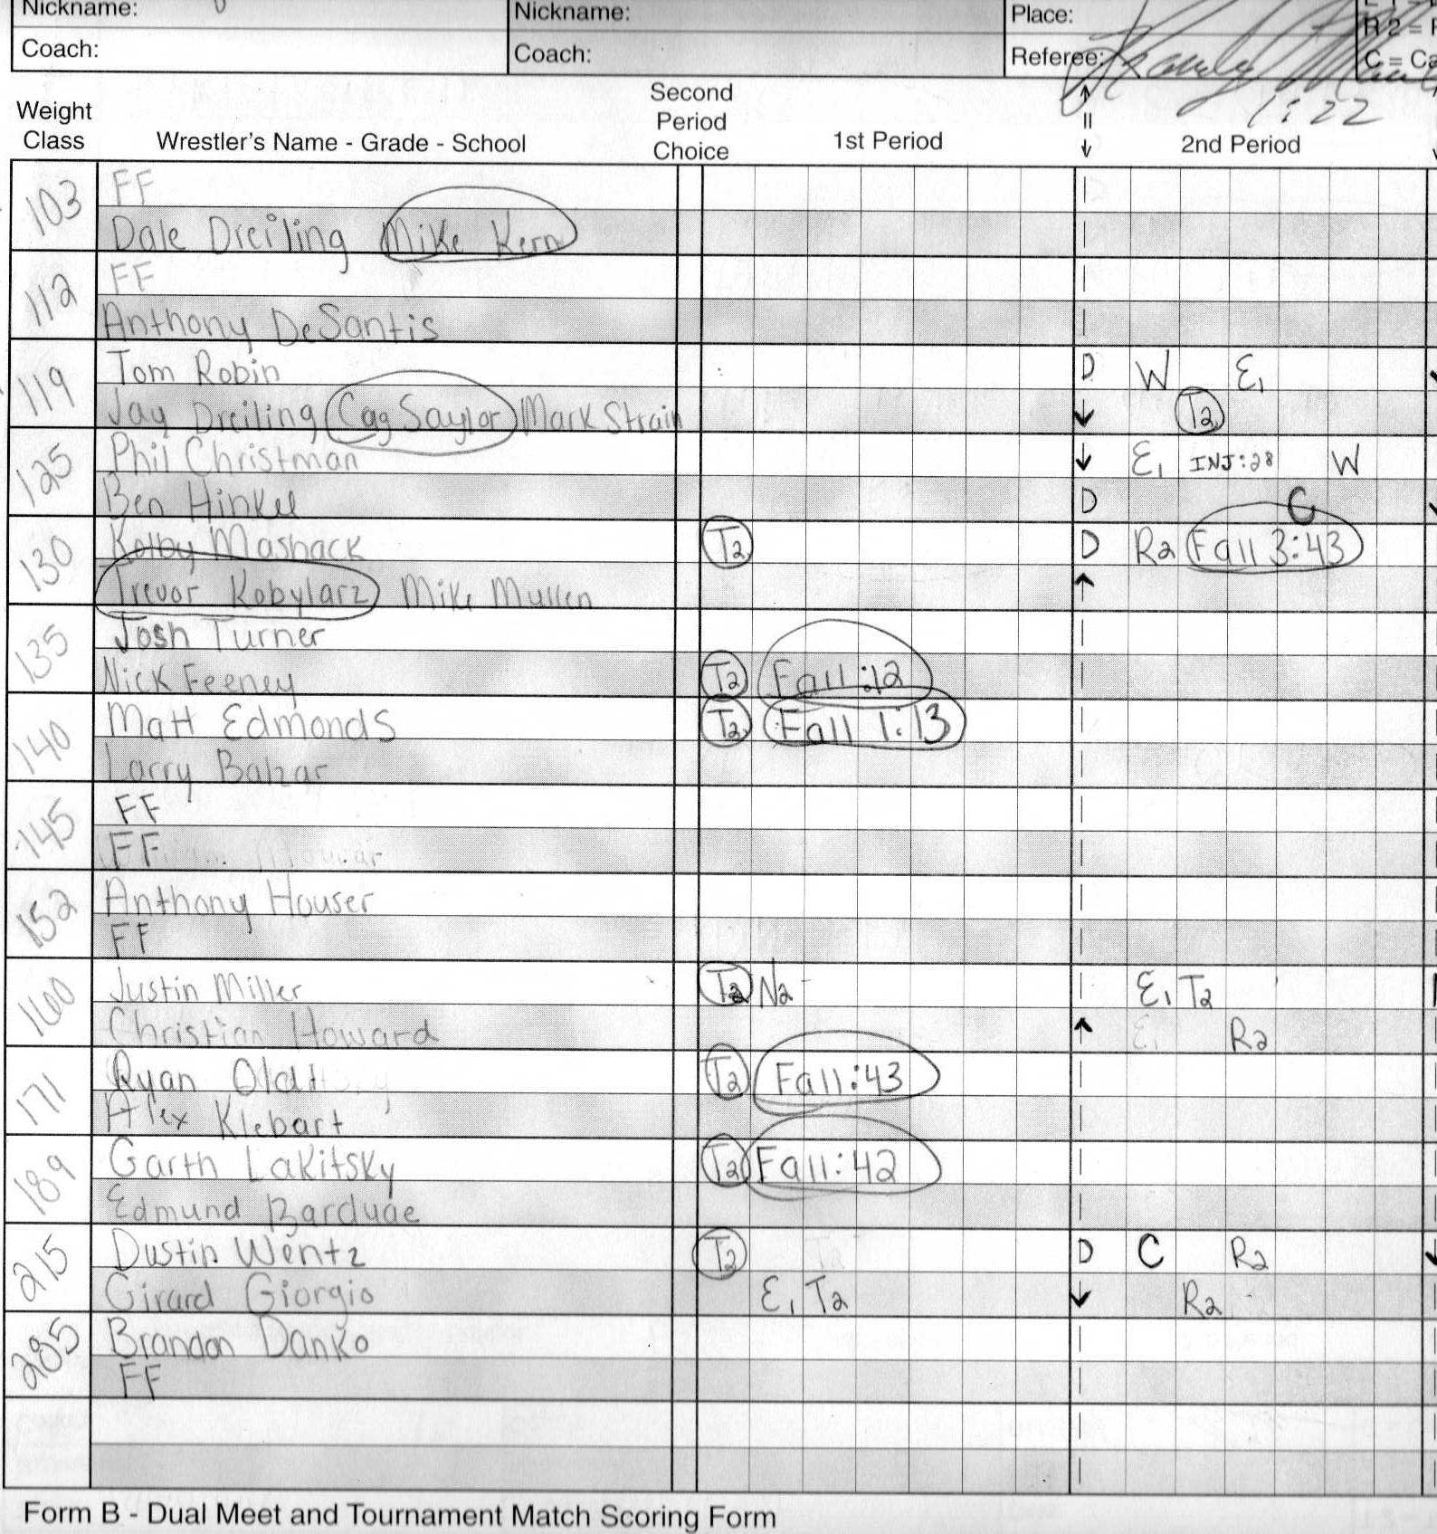
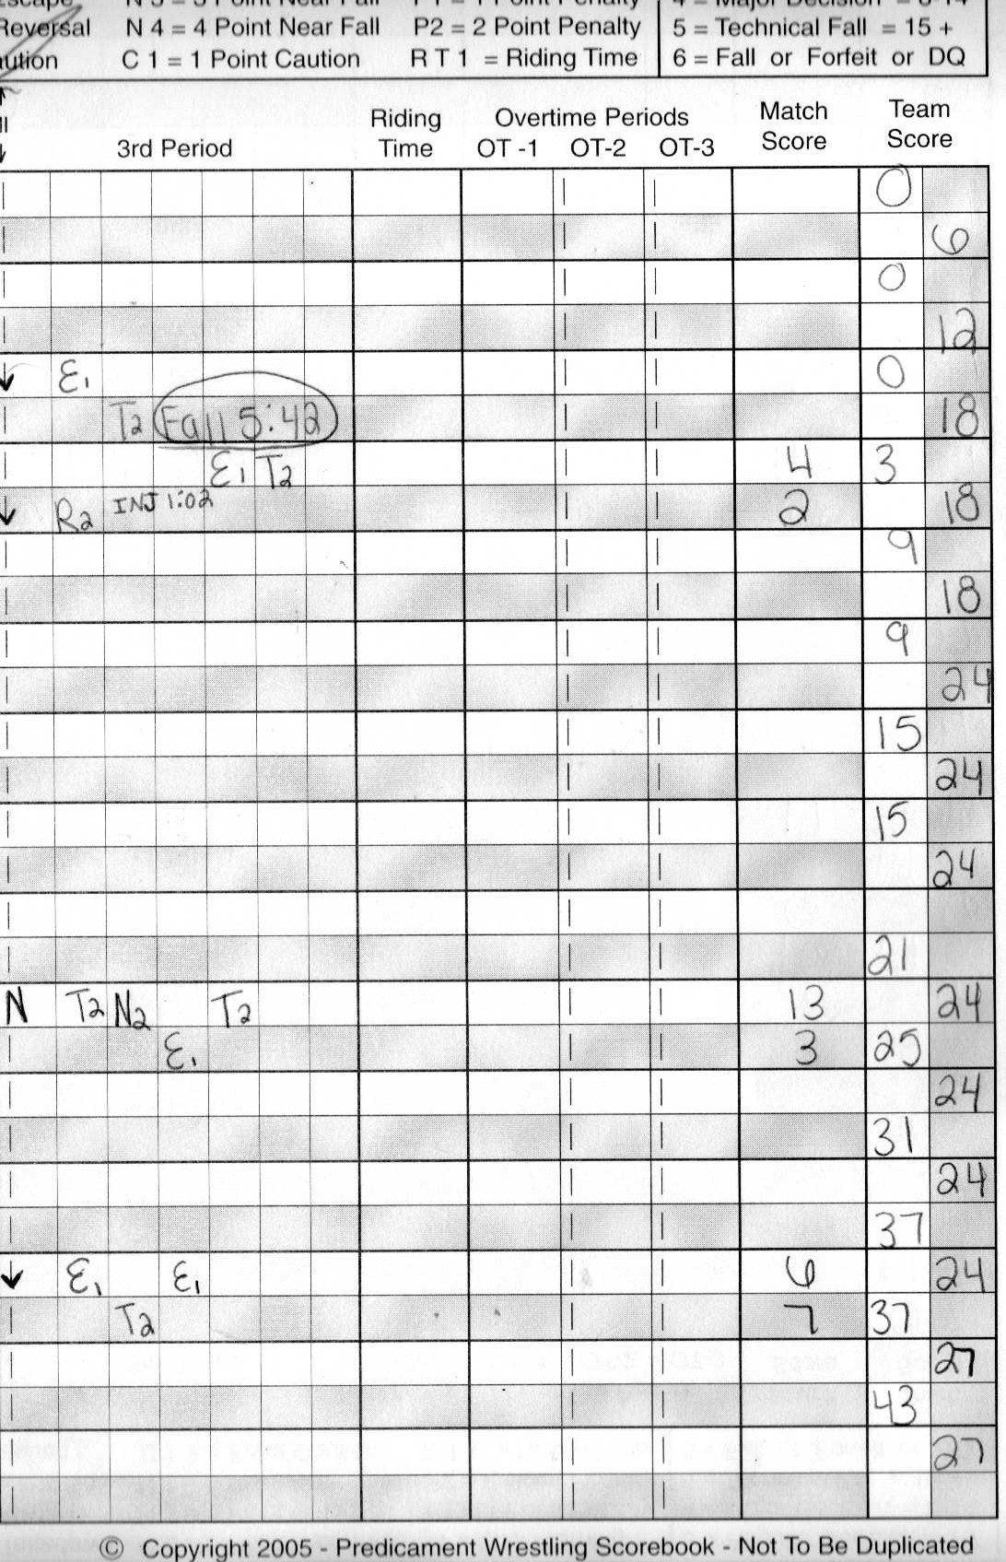

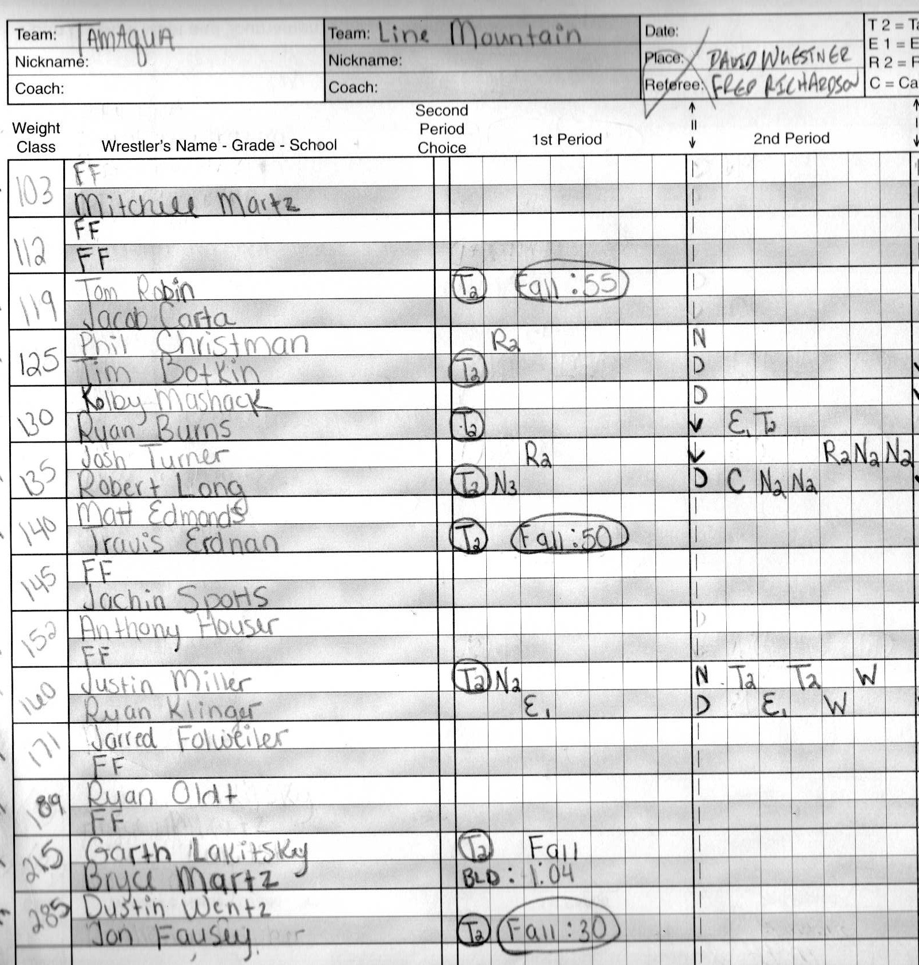

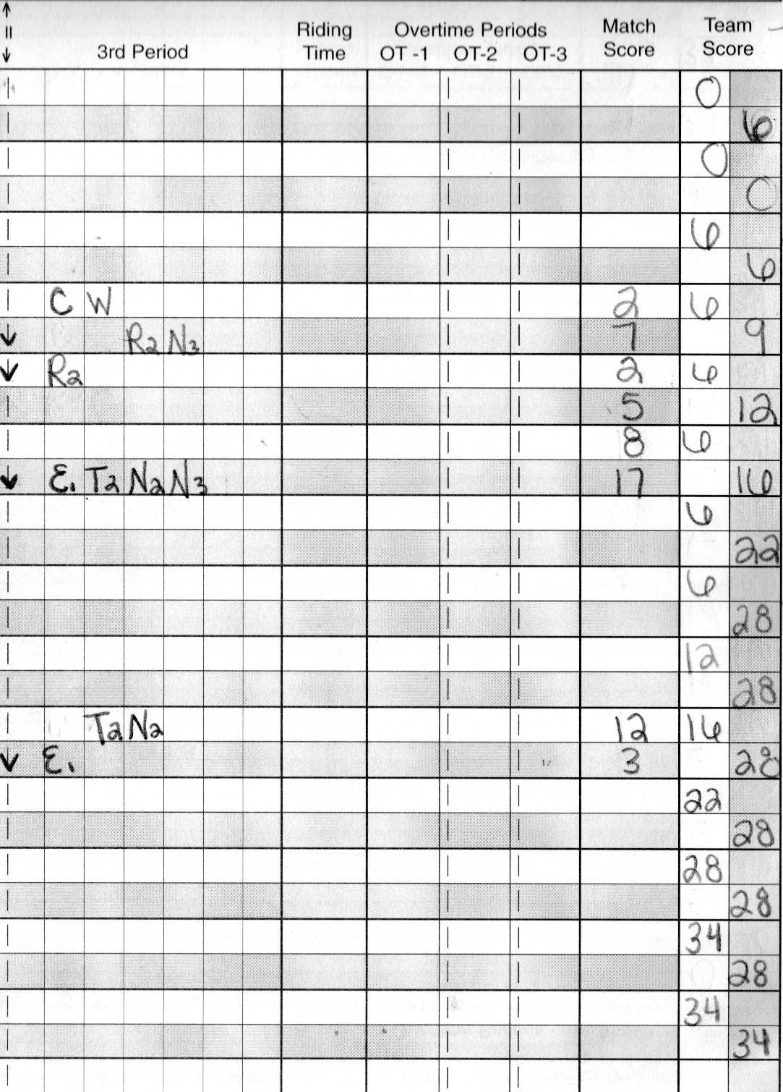

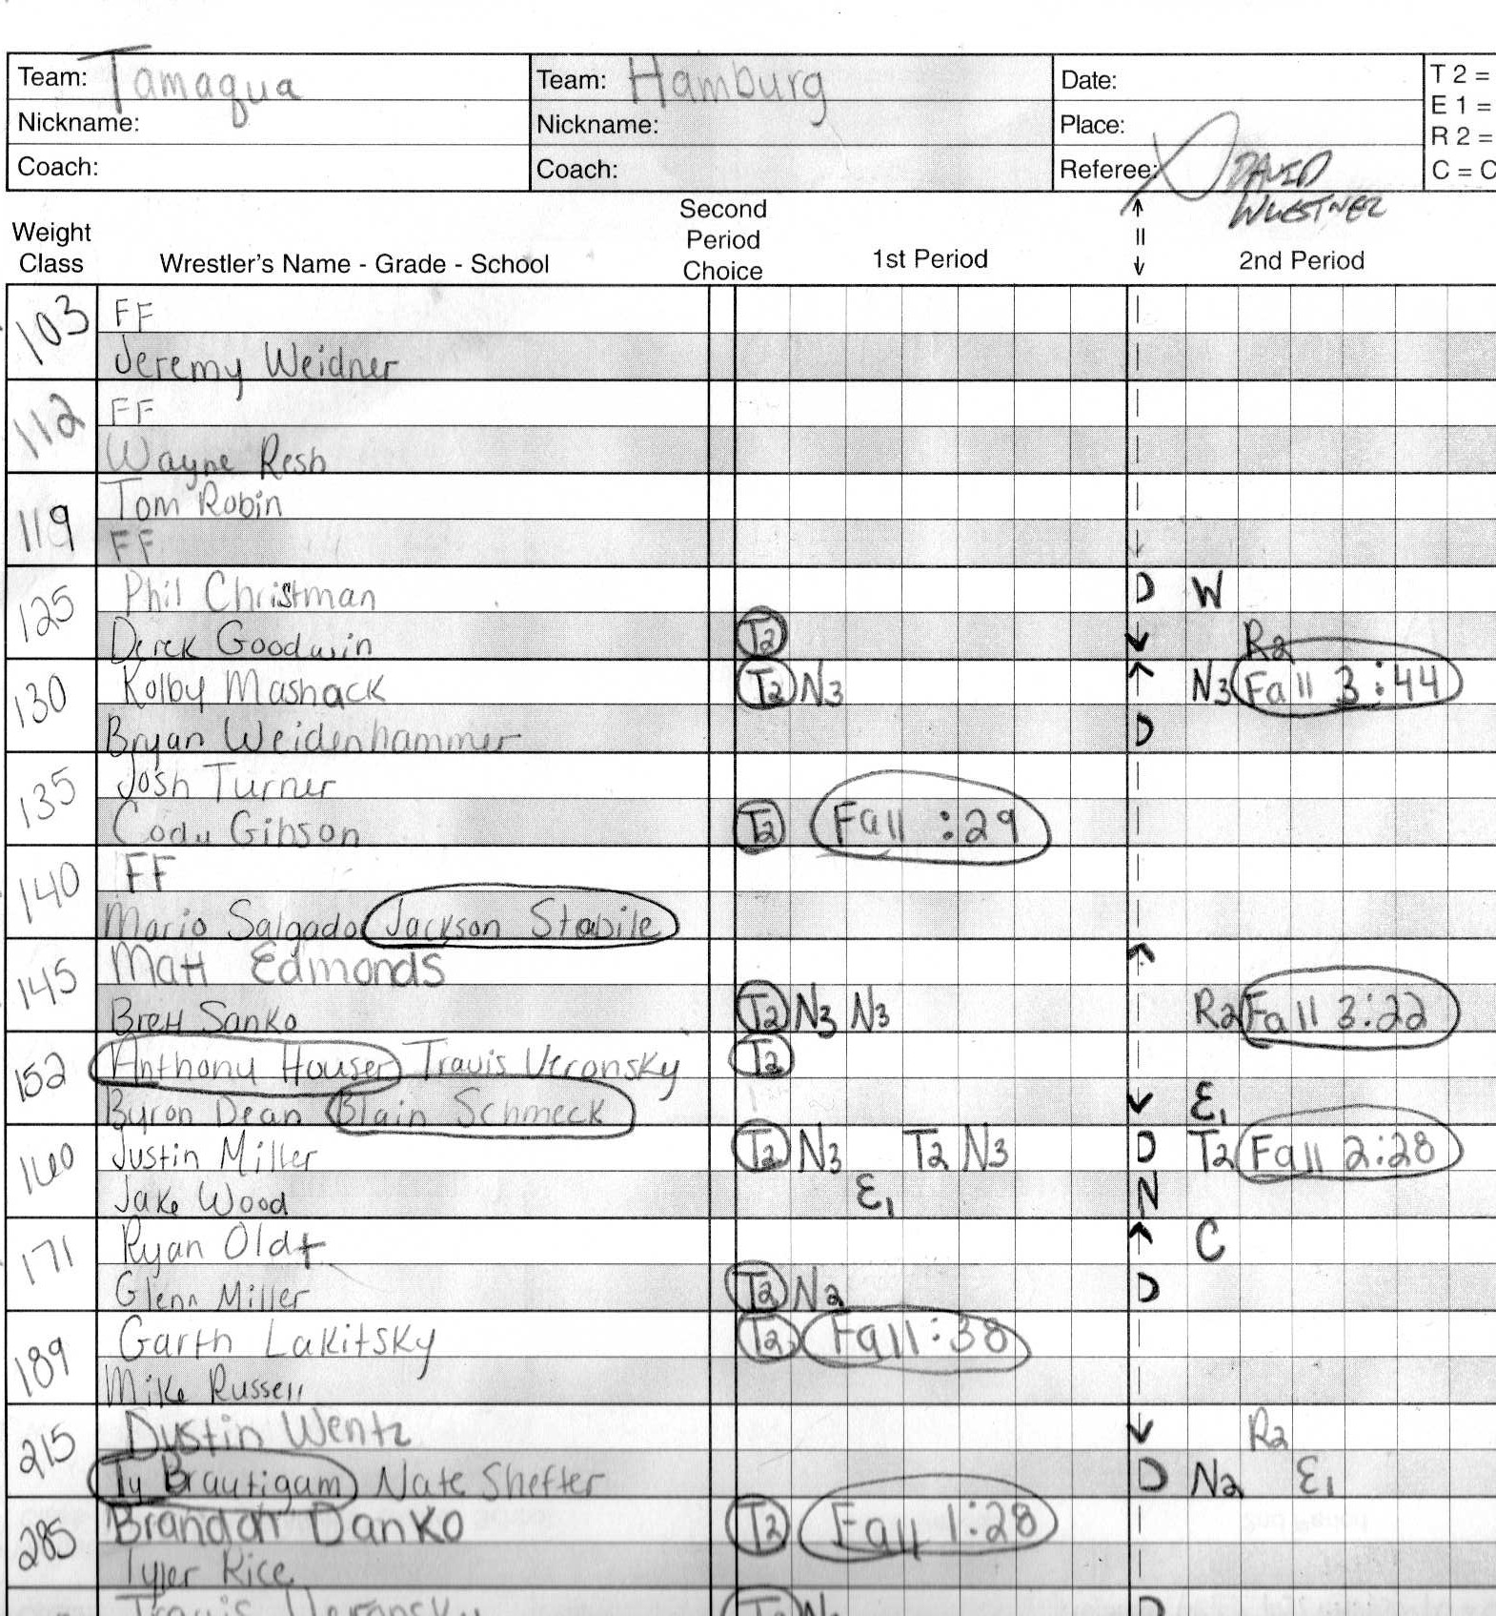
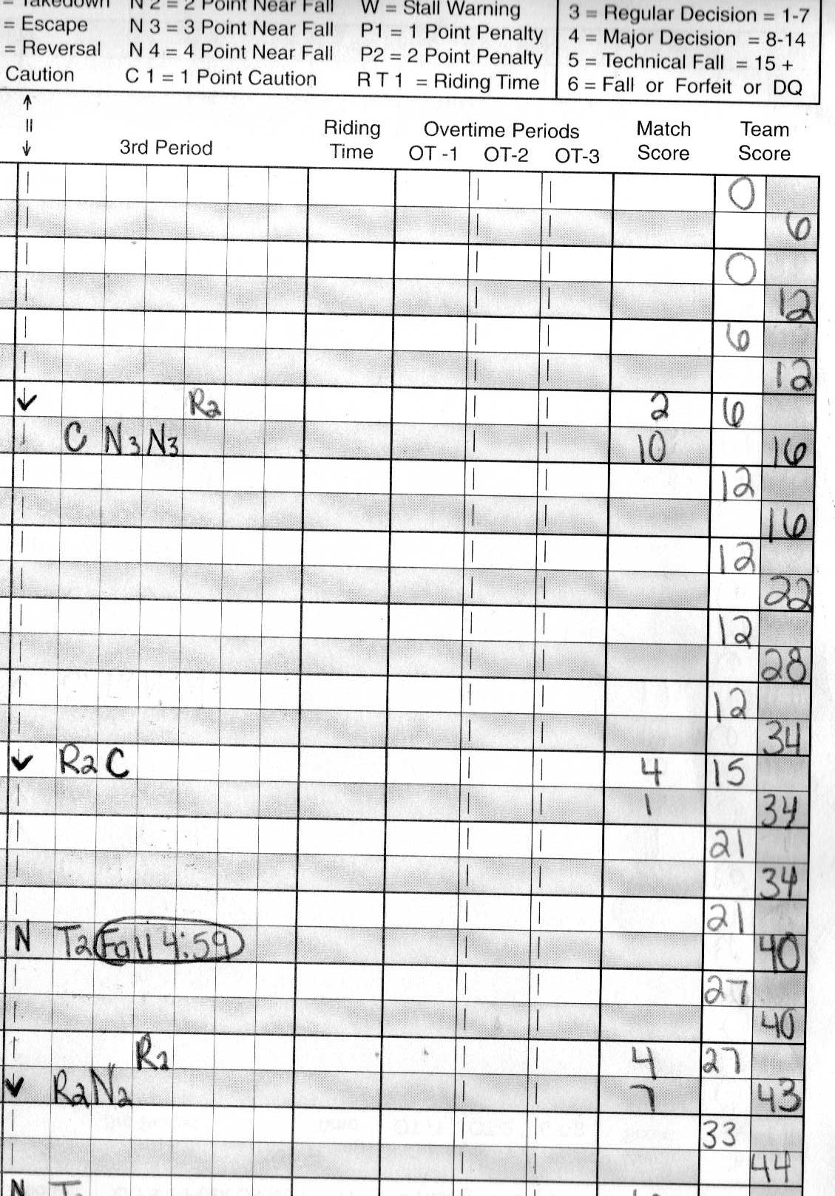

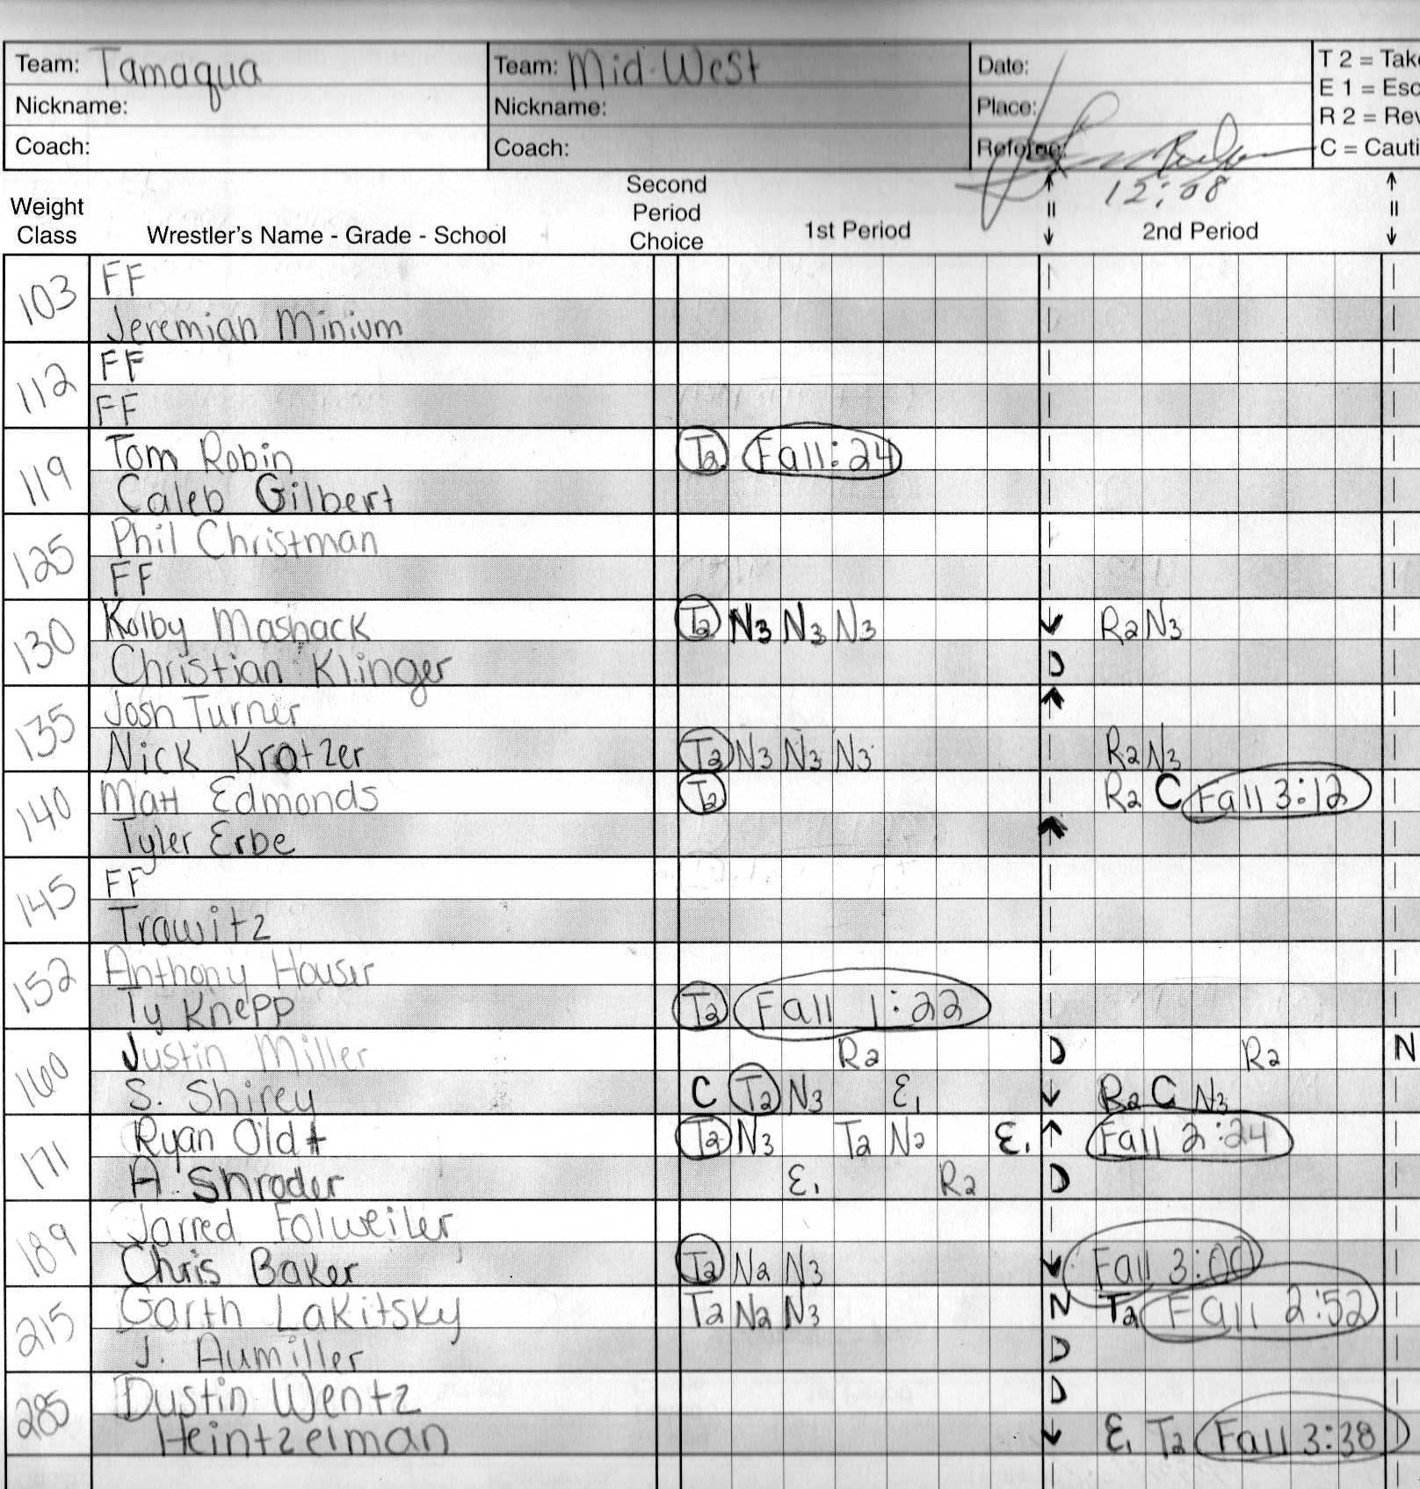
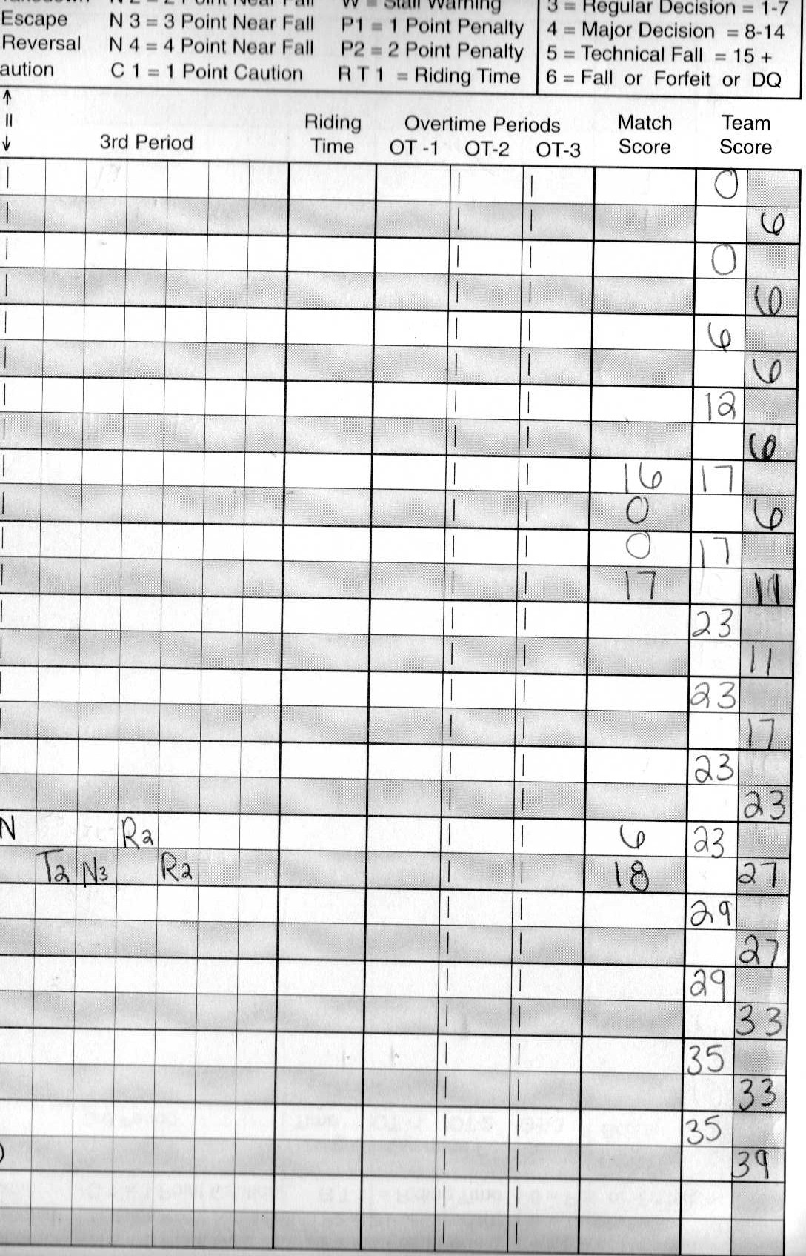

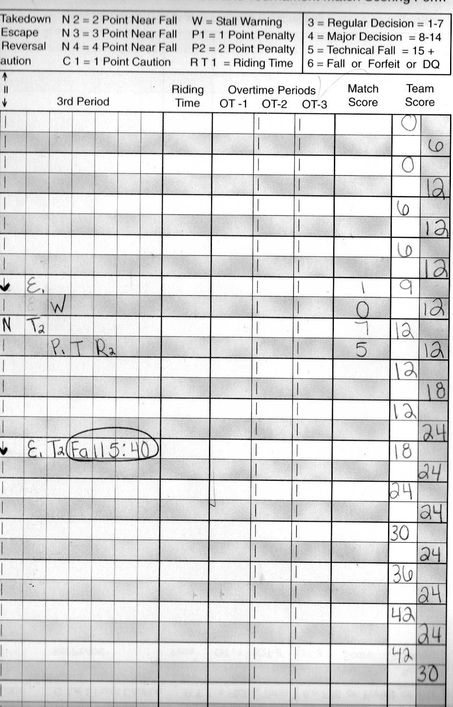
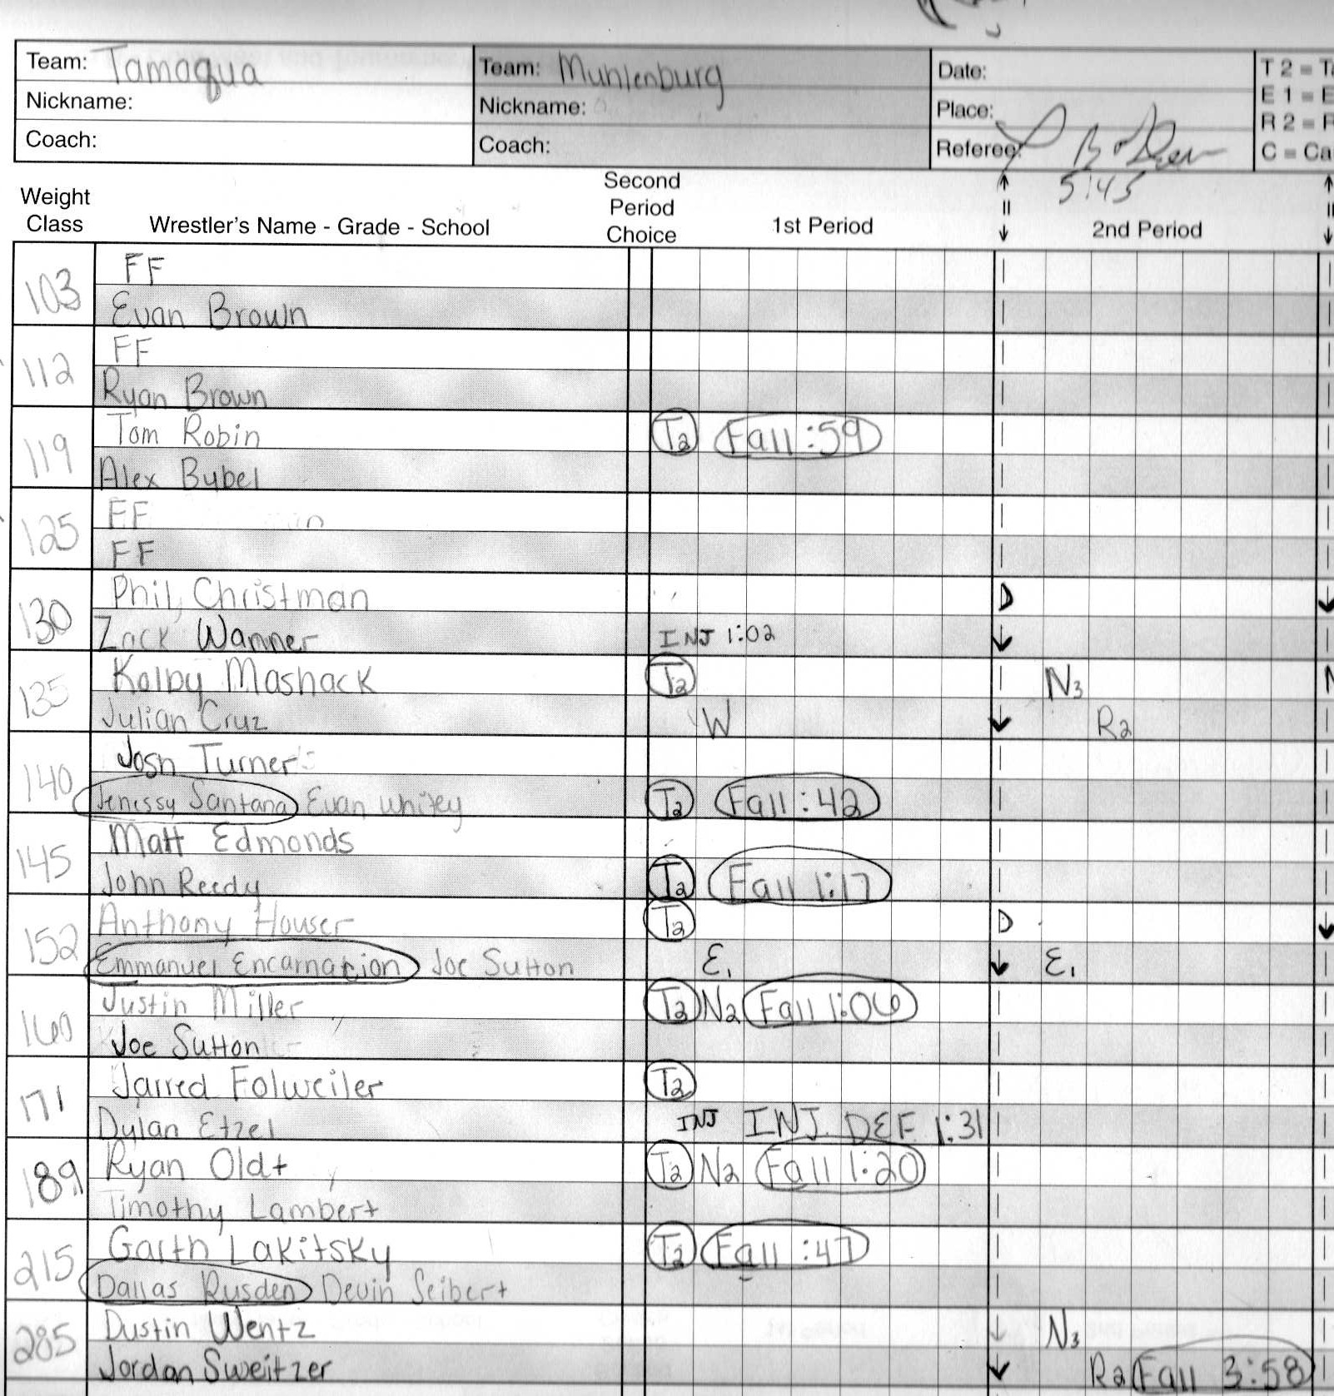

Berwick Tournament

Tamaqua finished 3 - 2 placing Second overall

Tamaqua 40 Mifflinburg 33
103 Sheesley M wbff
112 Dff
119 Catherman M wbf Tom Robin T 2:43
125 Struble M wbd Christman T 9 - 8
130 Mashack T wbff
135 Miller M wbf Turner T :59
140 Mellor T wbff
145 Edmonds T wbff
152 Houser T wbff
160 Snook M wbf Veronsky T :48
171 Oldt T wbmd Snyder M 17-6
189 Lakitsky T wbf Heeter M 4:52
215 Wiand M wbf Danko T 1:14
285 Wentz T wbf 1:59 Regal M

Tamaqua 33 Blue Ridge 42
112 Gajewski BR wbff
119 Esposito BR wbf Robin T 5:43
125 Christman T wbmd Church BR 14 - 2
130 Mashack T wbtf Griffen BR 17-2
135 Decker BR wbf Turner T 2:20
140 Pipitone BR wbd Mellor T 4-3
145 Stanton BR wbf Edmonds T :49
152 S. Kruger BR wbf Veronsky T 3:18
160 Miller T wbf Z. Kruger BR :44
171 Oldt T wbf House BR :27
189 Lakitsky T wbf Warner BR :31
215 Danko T wbff
285 Botts BR wbd Wentz T 7-6
103 Phillips BR wbff

Tamaqua 39 Abington Heights 36
119 Robin T wbff
125 Christman T wbf Strein AH 2:31
130 Mashack T wbd Pascale AH 12-7
135 Langon AH wbf Turner T 4:56
140 Edmonds T wbf Lobada AH 2:10
145 Fruehan AH wbf Mellor T 1:18
152 Gagliardi AH wbf Houser T 1:40
160 Miller T wbf Rosenstein AH 3:05
171 Oldt T wbf Burrier AH 3:43
189 Lakitsky T wbf Nole AH :07 * school record
215 M. Craig AH wbf Wentz T 2:18
285 E. Craig AH wbf Danko T : 30
103 DFF
112 Cadden AH wbff

Tamaqua 40 West Scranton 32
125 Levins WS wbd Christman T 9-4
130 Mashack T wbd Zackoski WS 8-2
135 Kobrynich WS wbf Turner T 1:35
140 Mellor T wbf Geissinger WS 1:23
145 Henry WS wbf Edmonds T 3:45
152 Houser T wbd Murry 9 - 0
160 Miller T wbd Marinucci WS 7-3
171 Oldt T wbf Limberg WS :10
189 Lakitsky T wbf Butsko WS 3:11
215 Wentz T wbf Lewis WS :48
285 Danko T wbf Eisenhart WS 3:06
103 Henry WS wbff
112 Jakes WS wbff
119 Eltora WS wbf Robin T 1:55

Tamaqua 29 Troy 39
135 Leiby Tr wbf Turner T 1:06
140 Edmonds T wbd Serrano Tr 10-8
145 Weed Tr wbf Mellor 5:28
152 Rockwell Tr wbd Houser 10-5
160 Miller T wbd D. Leiby Tr 5-3
171 Oldt T wbd Spiak Tr 9-0
189 Lakitsky T wbf Boor Tr 1:03
215 Berthe Tr wbf Wentz T 1:51
285 Tedesco Tr wbf Danko T 1:34
103 Vermilya Tr wbff
112 Johnston Tr wbff
119 Robin T wbmd Calkins Tr 14-4
125 Christman T wbd Summers Tr 7-1
130 Maschack T wbf Granata Tr 1:09

Bloomsburg Tournament:

Team – 7th

Individuals:

Ryan Oldt - Champ 160
Garth Lakitsky - Runner Up 189
Kolby Mashack - 3rd Place 130
Seth Mellor - 4th Place 140

2008 Darren Klingerman Invitational Wrestling Tournament
Bloomsburg Middle School
12-05-2008

Championship
103 Seth Miller, Kennard-Dale High School Fall Jared Hahn, Bloomsburg High School, 1:17
112 Daniel King, Susquehanna Township High School M-Dec Aaron Perez, Dallas High School, 14-2
119 Brock Gallaher, Forrest Hills High School Dec Christian Diamond, Tussey Mountain High School, 7-5
125 David Fogle, Forrest Hills High School Dec Josh Lahr, Shamokin Area High School, 6-3
130 Brandon Pesarchick, Shamokin Area High School Dec Victor Bracey, Kennard-Dale High School, 6-4
135 Derek Shingara, Shamokin Area High School Fall Bobby Kresch, Bloomsburg High School, 4:37
140 Matt Marcheski, Shamokin Area High School Fall Casey Cunningham, Mahanoy Area High School, 1:59
145 Bryar Robinson, Kennard-Dale High School T-Fall Leon Supsic, Shamokin Area High School, 17-2 3:10
152 Colton Eyer, Bloomsburg High School Dec Robert Tupper, Susquehanna Township High School, 8-3
160 Ryan Oldt, Tamaqua Area High School M-Dec Robert Bopp, Forrest Hills High School, 8-0
171 Ashtian Corbin, Susquehanna Township High School Dec Adam Goeringer, Dallas High School, OT 13-10
189 Nick Domanski, Shamokin Area High School Dec Garth Lakitsky, Tamaqua Area High School, 6-3
215 Nick Page, Kennard-Dale High School Dec Zach Glessner, Forrest Hills High School, 3-0
285 Robert Oshaben, Forrest Hills High School Dec Averee Robinson, Susquehanna Township High School, 7-6

Consolation
103 Brain Smith, Sullivan County High School Fall Kyler Runk, Tussey Mountain High School, :59
112 John Elick, Hanover High School Fall Robert Miller, Kennard-Dale High School, 3:50
119 Corey Buckley, Bloomsburg High School M-Dec Joel Stephaney, Mahanoy Area High School, 10-2
125 John Stefanowicz, Kennard-Dale High School Dec Drew Reed, Loyalsock High School, 2-1
130 Kolby Mashack, Tamaqua Area High School Dec Alec Eggerton, Loyalsock High School, 6-3
135 R.J. Brydon, Forrest Hills High School Fall A.J. Thomas, Dallas High School, 4:29
140 Troy Franko, Bloomsburg High School M-Dec Seth Mellor, Tamaqua Area High School, 12-2
145 Chris Gallaher, Forrest Hills High School Dec John Eisenhower, Dallas High School, 7-0
152 Ty Gardner, Pottsville Area High School Fall Zach Carden, Forrest Hills High School, 3:40
160 Brett Thompson, Kennard-Dale High School Fall Devon Drum, Loyalsock High School, 3:43
171 Christopher Moss, Forrest Hills High School Dec Frank Robbins, Bloomsburg High School, 5-2
189 Jeffery Meier, Forrest Hills High School Fall Joe Osick, Dallas High School, 4:43
215 Pat Green, Loyalsock High School Fall Nick Forte, Mahanoy Area High School, 1:44
285 Wes Tillett, Shamokin Area High School Fall Anthony Gipson, Hanover High School, 2:18

5th Place
103 Glen Nobel, Shamokin Area High School Advanced through BYE
112 Tanner Boyer, Loyalsock High School Dec Jimmy Harris, Pottsville Area High School, 2-1
119 William Delgrande, Kennard-Dale High School Dec Brandon Costenbader, Schuykill Haven High School, 2-0
125 Garrett Graham, Bloomsburg High School Dec Nathan Fegley, Mahanoy Area High School, 6-1
130 William Wolfhope, Forrest Hills High School Dec Alan Deitrick, Bloomsburg High School, 6-4
135 Matt Mullery, Hanover High School Fall Mason Pitts, Susquehanna Township High School, 1:47
140 Tyler Robinson, Kennard-Dale High School Dec Cody Bockelkamp, Susquehanna Township High School, 4-0
145 Kyle Miller, Susquehanna Township High School Fall Tony Tarlecky, Bloomsburg High School, 4:42
152 Steve Pask, Hanover High School Fall Matt Hilstosky, Dallas High School, 3:27
160 Josh Bussard, Tussey Mountain High School Dec Mark Szot, Dallas High School, 4-2
171 Kegan Polastre, Shamokin Area High School Frft Cody Harriman, Sullivan County High School
189 Ryan Longenberger, Bloomsburg High School Frft Dieter Holman, Mahanoy Area High School
215 Robert Terell, Susquehanna Township High School Fall Scott Daube, Dallas High School, 3:40
285 Sean Foster, Tussey Mountain High School Fall Ryan Jones, Kennard-Dale High School, 2:34

